Ticket Booking System BookMyShow
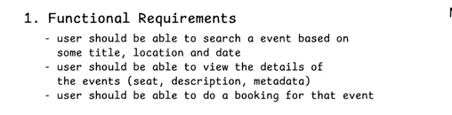
- Users can register, log in, and manage their profile.
- The system should handle concurrent bookings and ensure seat availability is updated in real-time.
- The system should support different types of seats (e.g., normal, premium) and pricing.
- The system should allow theatre administrators to add, update, and remove movies, shows, and seating arrangements.
- Send booking confirmations via email or SMS.

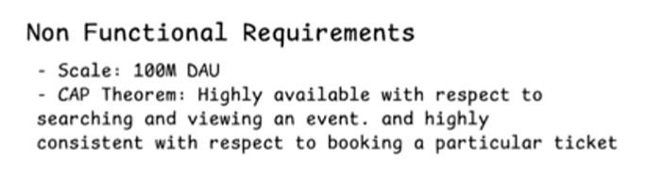
- Low latency for seat selection (<200ms)

API Designing
1)POST: v1/api/users/register – Registers a new user with name, email, phone
2)POST: v1/api/users/login – Authenticates the user and returns a new session token
3)GET: v1/search?q={searchItem}&location={location}&date={date} -?Returns the list of events in pagination form ie List<Event>events
4)GET: v1/event/{eventID} – Gives the event details & Location and Seats[]
5)POST :v1/booking/reserve
{
List<Seats>seats
}
and v1/booking/confirm
{
bookingId, paymentDetails
}

HLD Overview
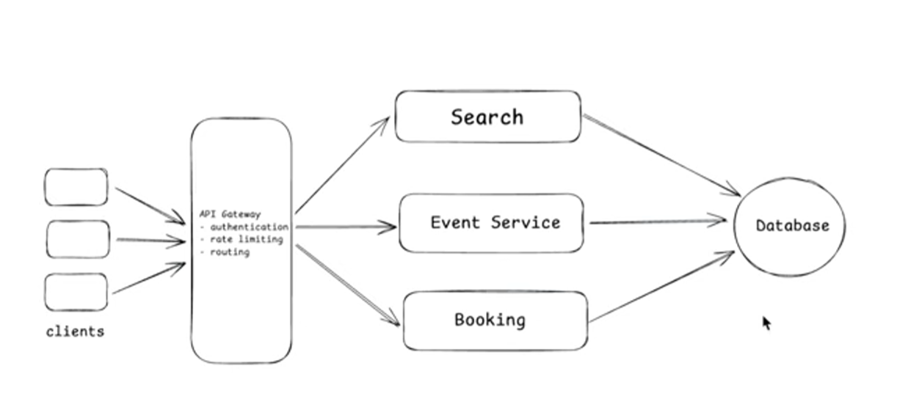
HLD Deep Overview
Cassandra DB
The event services stores metadata about the events, seats, description of the movie, place, location. To handle massive amounts of data across multiple servers with zero downtime. It provides continuous availability, blazingly fast write speeds, and prevents data loss even during hardware failures. So for event service to store large amount of metadata about the event we go for this database.
MySQL DB
In booking service we handle all the important information related to the seat reservation, seat confirmation, handling concurrency and making the payments so for this we want the system to be highly consistent. So the best choice for this would be MySQL or PostgreSQL. It is used for strong consistency and also for its ACID properties.

So, when the request comes from the client it goes through the API Gateway and when the search request is hit it queries the Cassandra dB . It is highly write optimised not read optimised. So, for every search operation it will take lot of time which will cause the performance issue. So, to optimise the search engine so that latency becomes minimum we can go for elastic search. Elastic search is highly optimised for searching.
So now the search engine will query the elastic search DB.
But now question comes how the data will come from Cassandra to elastic search. We can use cron job to feed the data from Cassandra DB to Elasticsearch DB.
Also, why I am choosing Cassandra can’t I go with MYSQL?
Actually, the search query will have multiple parameters like search based on location, date, time, movie so this means we need to apply indexing on multiple parameters which is a very bad choice. So, we choose Cassandra DB.
So, we now go with CDC(Change Data Capture) pipeline which injects the data from Cassandra to Elasticsearch DB.

Now in the Cassandra DB we have parameter called seats. So, whenever requests come inside the booking service it should basically decrease the seat count from cDB as well update that information in the MySQL DB.

Handling concurrency in booking service
If two users try to book the same seat, then how to handle?
Let’s suppose we have two users u1, u2 and they try to book two seats L12, L13
Suppose u2 request comes first. So we see that the seats are empty so we reserve that seat for u2 till 5 to 10 minutes until he completes the payment. So when u1 request comes it will see that the seats are already booked and it can be shown in grey symbol.

Consider two scenarios:
a)u2 made the payment: Booking service will call another service which is the payment gateway. Once payment is done the acknowledgment will again come to the booking service. So now booking service will change the status of the seat in Cassandra DB to booked or occupied.

B)u2 didn’t make the payment
Here to make sure the seat is not reserved forever we can write a cron job which keeps on checking whether the reserved seats have crossed the 5 minute or 10-minute timestamp or not. If the 10 min is crossed and user not made payment, then change it to available. This is complex thing to do because cron job has to run each minute not a good solution. It is not a reliable solution.
So, the other approach is to get rid of cron job we can introduce Redis cluster. Suppose u2 is booking the seats, the request will go to booking service and first we will check if it is present in the Redis or not. If it is not there then we store that information in the Redis and we will set timer TTL to 10 minutes and then it will go to payment service and upon confirmation we will remove the entry from the redis and then update in the MYSQOL and update in Cassandra DB that seat is confirmed.
If payment fails, then after the TTL expiration it will automatically get deleted from the redis cluster.

Since this is a microservice architecture the read ratios will be comparatively high than write ratios. So, it should be scalable.
When large amount of data is there, we can make use of Kafka.

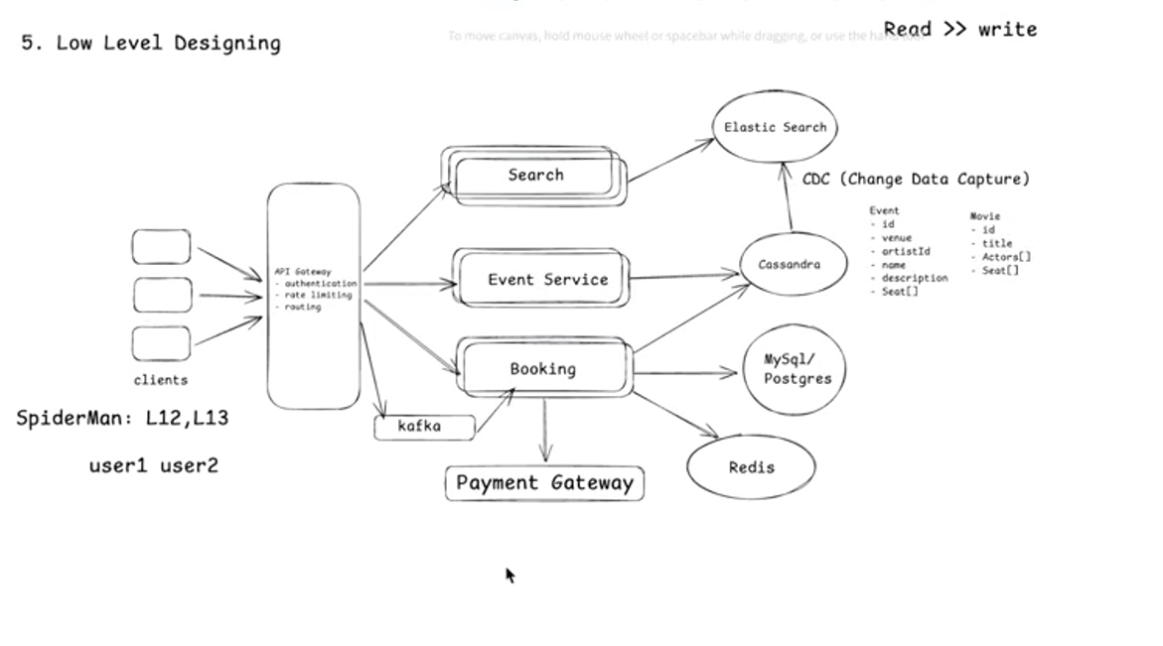

Design Patterns to Use
a)State Pattern
The State Design Pattern is a behavioural design pattern that lets an object alter its behaviour when its internal state changes by encapsulating state-specific behaviour into separate state classes.
A seat should not just be “available/booked.” It should move through states such as:
- Available
- Held
- PaymentPending
- Confirmed
- Released
- Cancelled

b)Saga Pattern for booking + payment + confirmation
Booking is a distributed transaction:
- Hold seat
- Start payment
- Confirm booking
- Send notification
These steps span multiple services, so a normal DB transaction is not enough.

c) Strategy Pattern for pricing
Your system supports different seat types and pricing .
Instead of hardcoding price rules, use strategies:
- Normal pricing
- Premium seat pricing
- Weekend pricing
- Surge pricing

d)Factory Pattern for payment providers / notification channels
You already have payment and email/SMS confirmation in scope .
Use Factory for:
- Payment gateway selection
- Notification channel selection
Examples:
- Razorpay / Stripe / PayPal
- SMS / Email / Push notification

